Hello Families,

Below you will find an IF…Then chart. This chart can be used to help set clear expectations and serve as a motivator for your child. You will notice the chart below has 3 different options. One has just words, another has just pictures, and the last option has both pictures and words. Decide which one would most benefit your child (feel free to get their input). Then consider what reward of choice is available and works for your household. I have provided an example one in there that you are welcome to use or if you have other activities that are better suited for child’s needs in the home setting that can be adjusted. Feel free to adapt this chart meet the needs of your child. Also I can create a customized one for you. I would just need feedback regarding what types of rewards are available and which subject areas you may need this for. I hope you find this to be a helpful tool.

Feel free to reach out regarding any questions or feedback with this learning strategy. Thanks for your continued support and all that you are doing to best assist your child with at home learning.

Thanks,

Ms. Evans

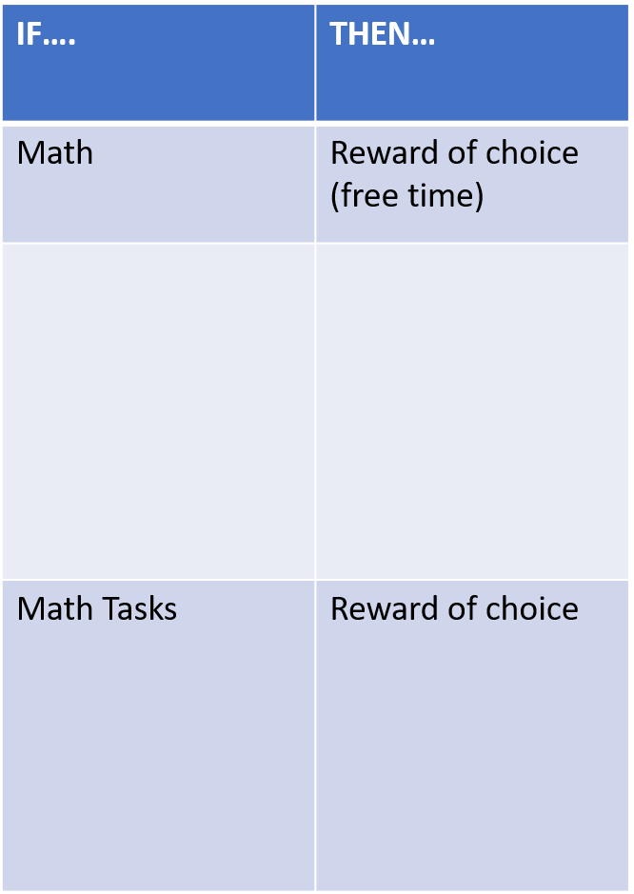

Just words

Just pictures

Words and pic picpci

Words and Pictures C

Hello again Families,

Below you will find a student check-in chart. This can be used to help your child self-assess their learner behaviors and/or emotions. The chart is broken down into each area of the at home learning day. Some areas can be omitted depending on how you have adapted the schedule to best meet the needs of your child. The faces are used as a simple rating scale.

Smiley face= I have tried my best and am working like a bulldog buddy. I completed my work the best I can.

Also, I am happy and feel good about what I did.

Middle face= I tried my best at times and sometimes was working like a bulldog buddy. I only completed some of my work and had some oopsies since I was not always giving it my best.

Also, I am feeling okay about what I did as at times I did good, but than other times I did not do so well.

Sad face= I did not try my best and was not working like a bulldog buddy. I may have even given up completely.

I am feeling sad or mad that I did not do my best and know that I can do better.

You can help your child fill out the chart or you can let them try to fill out the chart on their own and see if you agree. When using this chart, it is best practice to assess after each subject area. However, on some occasions children do not respond to this immediate feedback and may need to wait till end of day to review chart. Please do whatever works best with your child.

You can set up goals for your child and have them work to earn something for a certain number of smiley faces. You can also just use it as a tool to have conversations and help your child understand areas of at home learning they are doing well and other areas they may need to keep working on. The chart also has tips on the left and encouraging statements.

I hope once again you find this tool useful. If you have any questions or concerns regarding implementation or how to adapt it, please let me know and I would be happy to help.

Thanks again for your continued support and all that you are doing to best assist your child with at home learning.

Ms. Evans

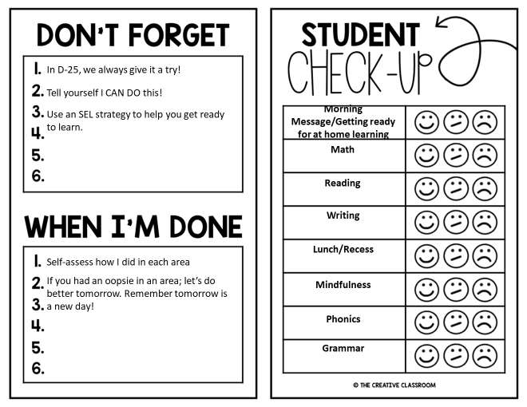

**Morning Meeting**

**Independent Work**

**Brain Breaks**

**Science**

**Fundations**

**Wit & Wisdom**

As a bulldog buddy, we always give it a try.